NEW VERSION – MENSTRUAL CYCLE (March 2025 KTR)

Men have the reproductive hormone testosterone, which is produced continually and is always present in the body.

Women, on the hand, produce several different reproductive hormones. These hormones fluctuate on a monthly cycle, which leads to monthly fluctuations in:
- physical condition (energy levels, period pains, etc)
- emotions / mood

Day 1 Cycle begins with vaginal bleeding
Aka period / menses / menstruation, for approx. 5 days
During period: lack of energy, physical pain
After end of period: more energy, a sense of a new beginning
Approaching ovulation: more energy, increased sex drive
Day 14 Ovulation
Approaching end of cycle: anxiety, irritability
Day 28 Cycle ends

The female reproductive cycle is an example of an infradian rhythm. The cycle is controlled by four hormones. Essentially, it is a coordinated sequence of four ‘waves’ of hormones, one after the other. These hormones are produced in a specific order. Each hormone has a specific job. As follows:
- Follicle stimulating hormone. Produced by the pituitary gland (the ‘master gland’, found in the brain). Levels begin to rise shortly after the start of the cycle. FSH brings about the following changes:
  - an egg matures in one ovary
  - oestrogen production is stimulated
- Oestrogen. Produced by the ovaries. Oestrogen brings about the following changes:
  - the uterus lining thickens up
  - clearer thinking, better sense of smell, feeling of new beginning
  - FSH production is inhibited
  - luteinizing hormone production is stimulated
- Luteinising hormone. Produced by the pituitary gland. LH brings about the following changes:
  - energy levels and sex drive increase
  - the mature egg is released from the ovary (aka ovulation)
  - oestrogen production is inhibited
  - progesterone production is stimulated
- Progesterone. Produced by the ovaries. Progesterone brings about the following changes:
  - the thick uterus lining is maintained
  - LH production is inhibited
  - now there is nothing to stimulate progesterone production, so progesterone starts to fall (unless there is a pregnancy – if so progesterone levels rocket!)
  - falling progesterone levels cause depression, anxiety, irritability and mood swings
  - low progesterone levels cannot maintain the uterus lining any more, so it breaks down.
This is summarised in the diagram below.
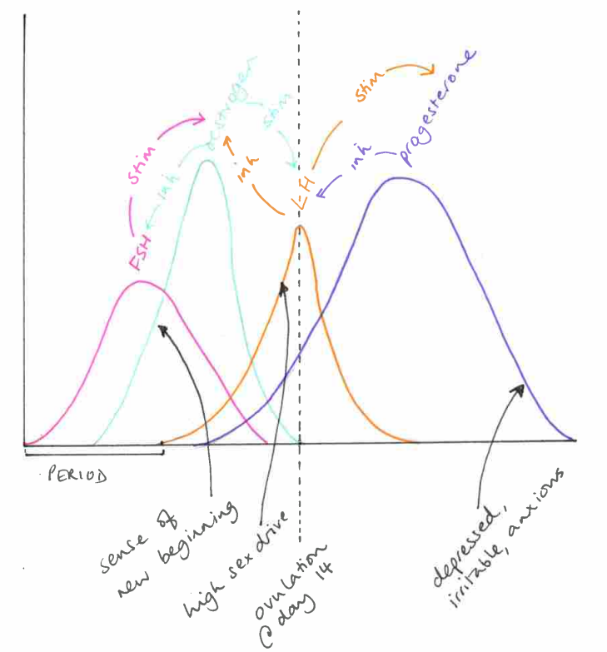

How to write this in a paragraph? It would depend on the essay question, but here’s quite a generic example.
The menstrual cycle is a (usually) 28-day cycle controlled by a sequence of hormonal changes. These are designed to get the body ready for pregnancy, and bring about behavioural changes that can lead to pregnancy. From the beginning of the cycle, there are four controlled ‘waves’ of hormones which act as endogenous pacemakers. These hormones are: follicle stimulating hormone, oestrogen, luteinising hormone, then progesterone. Each hormone (endogenous pacemaker) controls the production of the next hormone, while suppressing the production of the previous hormone. Each hormone has specific effects on physiology and psychology. For example, in the first half of the cycle oestrogen has the physiological effect of causing the uterus lining to thicken, and the psychological effect of lifting mood, and giving a sense of ‘new beginnings’. Then, in the middle of the cycle, luteinising hormone has the physiological effect of causing ovulation, and the psychological effect of increasing sex drive. Thus we can see clearly that this monthly cycle is dependent on endogenous pacemakers, and entirely geared towards reproduction.

